Dissatisfaction with the Supreme Court Spans the Political Spectrum
Focus groups reveal that Americans are highly critical of the current Court and support reforms to make it more impartial and accountable.
By Gabriella Sanchez
As the Supreme Court weighed consequential issues this term, including birthright citizenship, election rules, and executive power, the public judged the Court itself. Poll after poll shows historically low approval ratings. That spells trouble for an institution whose legitimacy rests on the public’s confidence in and acceptance of its rulings.
To better understand these views, the Brennan Center organized three virtual focus groups with registered voters across the political spectrum, selected from respondents to previous Brennan Center surveys. Between March 14 and March 16, 2026, research analyst Cora Henry spoke with a group of six participants who identified predominantly as independents, a group of seven who identified predominantly as Democrats, and a group of eight who identified as Republicans. Their discussions explored the Court’s role, its recent performance, and reform proposals such as binding ethics rules and term limits — including the Brennan Center’s proposal for 18-year terms for the justices and staggered, regularized appointments.
Perceptions of the Court were largely negative, with critiques centered on politicization, unfairness, and lifetime appointments. Recognition of the Court’s immense power to shape the country magnified those concerns. Even participants who described their views as mixed or mostly positive struggled to name specific points of praise for the current justices. These discussions came before before the Court effectively destroyed what remained of the Voting Rights Act and expanded presidential power, among other moves that could have further angered the public.
Given this widespread discontent, it comes as no surprise that proposed reforms received strong support across groups. Every participant backed term limits. Many, however, doubted that term limits alone would be a cure-all and proposed additional solutions to bring the Court closer to their ideal.
Another through line was broader dissatisfaction with democratic institutions. Participants agreed that government is not working for ordinary Americans and that the Court is only part of the problem. Disapproval of Congress was universal, and participants repeatedly said Court reform proposals — including term limits, age limits, and stricter ethical standards — should be applied to lawmakers too. They expressed widespread cynicism about corruption and a desire for greater transparency and accountability, with myriad ideas about how to achieve this. (These results echo the findings of the Brennan Center’s recent poll on corruption.)
The discussions also revealed partisan divides. Participants’ views of the Court were closely tied to their opinions of the current administration. Checks and balances sometimes proved contentious, with support for this foundational American principle wavering when pitted against partisan loyalties or frustration with the status quo.
These findings add to the mountain of evidence that Americans are eager for change — at the Court and across government. Voters of all political stripes see term limits as a promising start. Any push for change, however, will need to convince disillusioned Americans that there is a viable path to enacting and implementing reforms.
Highlights from the discussions, edited for clarity and brevity, are shared below.

Participants
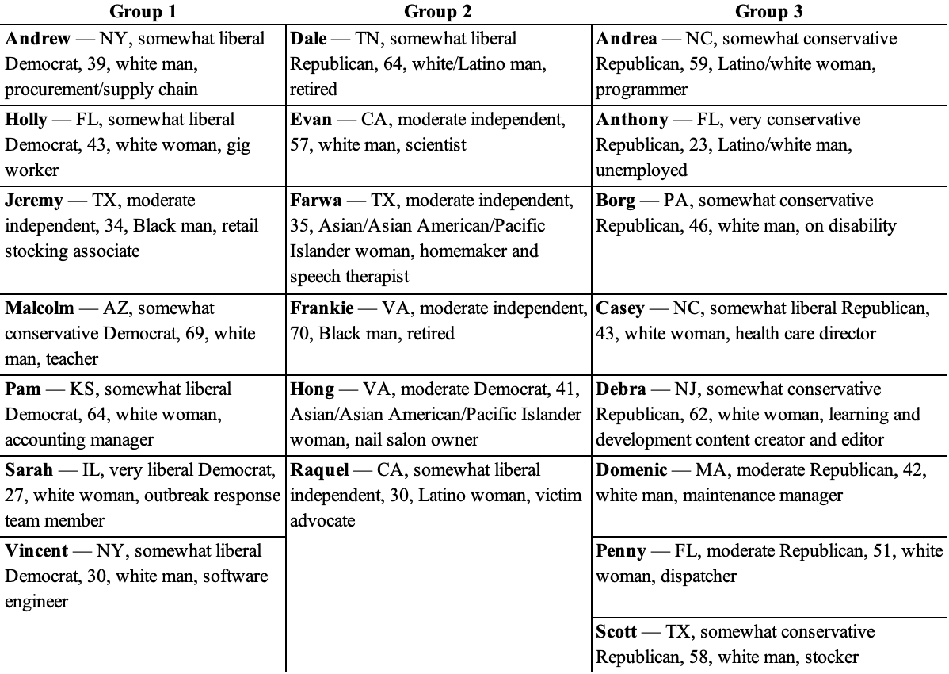

Perceptions of the Supreme Court
The Supreme Court’s central role in American life was a recurring theme in the discussions. Participants agreed that the Court is immensely powerful and its decisions affect all Americans, often in ways that are not immediately visible.
Evan (I, CA): When they rule on something, that’s it. There’s almost nothing you can do about it, given the current political situation.
Andrew (D, NY): It definitely clearly does affect my life. And I’m certain when I see a ruling, I know it’s going to have a downstream effect. It is slightly like throwing a rock into a pond, though. You see the ripple effects, but it’s going to take a while to get to you.
Domenic (R, MA): They have the power to change things that have rippling effects through a lot of different things and can affect a lot of people’s lives depending on their decisions.
Vincent (D, NY): Although Supreme Court rulings don’t feel like they affect me, they shaped a lot of what it is to be American.
Most participants named Brown v. Board of Education (ending segregation in public schools) and Roe v. Wade (recognizing a right to abortion) and alluded to Obergefell v. Hodges (recognizing a right to same-sex marriage) as among the most influential rulings in U.S. history. When asked to highlight recent decisions, multiple people said they don’t follow the Court closely, but members of all three groups mentioned the ruling against President Trump’s global tariffs and the overturning of Roe with Dobbs v. Jackson Women’s Health Organization. Moderate and liberal-leaning participants offered several additional examples of Supreme Court cases involving Trump and his administration’s policies, with mentions of decisions on federal immigration enforcement and presidential immunity.
Dale (R, TN): The tariffs, the Roe v. Wade, the same-sex marriage rulings, I think those are the ones that are the most important to us right now. I think these three are the ones that concern me because they’re the ones that are important to me and my feelings and my thoughts on the way that all Americans should be treated equal.
Frankie (I, VA): The president has done so many wrong things. Chaos is going on with the Supreme Court and the president right now. It’s so many rules and regulations this president has broken. I don’t study it that closely, but just to narrow it down, the tariffs is one of the biggest ones.
Sarah (D, IL): I’m concerned about the ruling that says the president can’t be held responsible for crimes committed in office and what that means for presidential power.
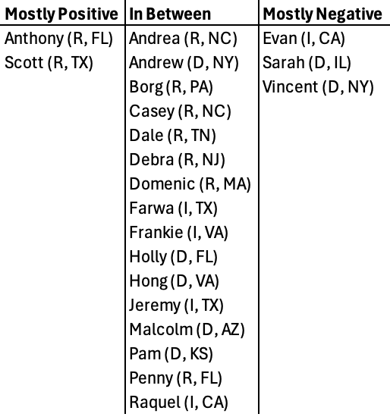
Three-quarters of participants described their view of the Court as somewhere between positive and negative.

Yet across all three groups, participants evaluated the Court critically. Even those who described their views as mixed or mostly positive quickly veered toward criticism, often aimed at perceived partisanship, lifetime appointments, and specific rulings they disagreed with. Praise, on the other hand, was more abstract, grounded in ideals about what the Court should be or, among independents and Democrats, lingering admiration for its past.
Mostly Positive
Scott (R, TX): I think I’m mostly positive just because they need to be there. There needs to be some court in the country that’s a final judge. I think they messed up on the tariff thing. I really do. And they shouldn’t be lifetime appointments. I think there should be some type of age restriction.
In Between
Penny (R, FL): There’s times when I think of them positively, and then there’s the times I think of them negatively. I think they should be there for the good of all of us. But then there’s times in the past few months when they’ve had to vote, and the vote was like, “Oh my God, what happened? They did what?” And then you start questioning, are the Supreme Court justices corrupted? How could you possibly vote this way? But then the next few votes, they do the right thing. So it’s a give and take. And sometimes it’s hard to see that when there’s 10 votes in a row and they’re just all bad.
Dale (R, TN): I think they’re doing some good stuff, but I don’t think they’re taking it as far as they could. Like, for example, this tariff ruling. They said they couldn’t do the tariffs, but they left the door open for the current president to go around it. And I don’t think that’s right. If the law of the land is decided by these nine justices, that should be the finale of it. We made a ruling. It’s done. Live with it. Don’t go around it.
Andrea (R, NC): I think, of course, they’ve done a lot of good. I personally wish they weren’t lifetime positions because something just doesn’t sit right with me with that. I can understand having a big chunk of time so that you can really get in there and know what you’re doing, but I just think after a while, that’s why I’m kind of in between.
Farwa (I, TX): Some of the positives that I see are human rights issues, coming up with things to stop segregation and things like that. But as far as negative, the Court is extremely biased now. And it has an unequal amount of people that are appointed, party-wise.
Hong (D, VA): A lot of the decisions they make are based on facts and common sense and what’s right. But I think what’s wrong is that some of the members— For example, one of the members publicly held all these interviews publicly siding with certain political parties, even though they are supposed to be a neutral party. So it’s my fear that they’re not going to make decisions based on what’s right or wrong. They’re basing it on their political belief, and that can harm people.
Andrew (D, NY): There have been plenty of decisions recently that I disagree with, but I do want to think that there still remain justices that vote against their party and surprise people. I do want to have some faith that there remains some level of discourse and dialogue and genuine thinking that’s happening when you actually come to the matters that are being argued in the Court.
Pam (D, KS): I believed in the Supreme Court keeping control of both Congress and the president. I loved it [during the time of Justices] Ruth Bader Ginsburg and Scalia, people who had differing opinions but had respect for each other. And I think it’s just been very skewed by the last few appointments, and it’s really changed. And it will take 10 or 15 years for that pendulum to swing back.
Mostly Negative
Sarah (D, IL): I think my positives for the Supreme Court are what it could be or what it’s intended to be, which is a check on the power of the other branches. But then my negative is how it is functioning in this case. It’s actually not functioning as a check.
Vincent (D, NY): I like the fact that they can operate somewhat independently, but that is an ideal perspective. I just think that’s not the case in recent history. I think they shouldn’t have any sort of political bias or leaning in how they see the law, but that is not the case at all.
Evan (I, CA): I’m feeling more negative toward the Court than I did in the past because I feel like they’re doing things that haven’t been done previously. They’re overturning precedents that typically they wouldn’t overturn, like Roe v. Wade. But they were pretty much put in there with that job. And even though they said, “Oh, well, we’ll consider precedent” when they did their [confirmation hearings], they get in there and they just overturn it. It seems like most of the opinions are fairly negative.
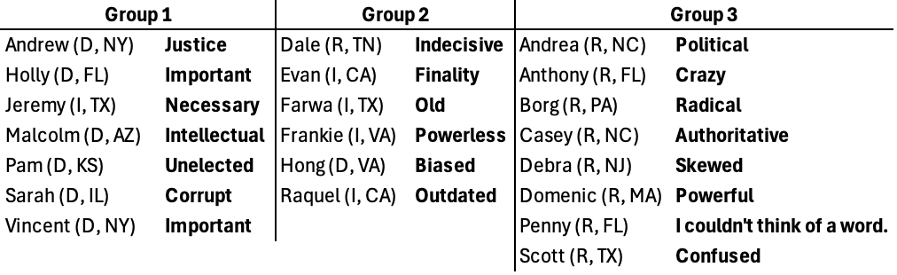
Criticism of the Court for being overly political and a desire for greater impartiality were themes. When asked to describe the Court using one word, most chose negative terms. Several participants, including Republicans, described the justices as politically biased or out of touch.

Politicized
Debra (R, NJ): I just think the justices are not being as objective as they were many years ago.
Andrea (R, NC): I think you can very clearly see if the justices are left- or right-leaning. I grew up thinking that they would be neutral, and I don’t feel that’s true. I think the Court is very political.
Borg (R, PA): The justices are not what they have been representing for a long time. It just seems political and just way off in a different direction.
Scott (R, TX): The justices are supposed to go by what is the law. But yeah, they seem to be acting pretty politically right now.
Evan (I, CA): My feeling is that the justices have become quite politicized, in terms of the left and the right, putting in people that are just more extreme when it should be just more moderate judges that interpret the law and take in more nuances. It just seems very polarized on the Court now.
Sarah (D, IL): Right now, I feel like there’s a lot of political pressure, especially on the right, to rule in a certain way. I’m thinking about people who were appointed to the Supreme Court by Trump, and the amount of power and influence Trump has. So I think there’s a little bit of quid pro quo happening there. He gave you the spot, and he has such power that you have to appease him in some ways.
Out of Touch
Raquel (I, CA): Systematically, sometimes the way that the justices interpret the law is on the basis of a very outdated America.
Farwa (I, TX): If you’re there for life, you have an older mindset versus what’s current or with the times.
Participants in the independent- and Democratic-majority groups were dissatisfied not only with who sits on the Court but with how they get there.
Andrew (D, NY): [The problem is] almost outside of the Court, with the nomination process, and the politics that go into the nomination process, and forcing Supreme Court justices to retire when you have the presidency, or denying nominations till the next presidency begins, and all those games.
Sarah (D, IL): When you can have people like Mitch McConnell hold the nominee hostage so that you can stack the Supreme Court and you can’t undo it until those people die or leave the Court, then there’s a big gap between what the Court could be and what it actually is.
Malcolm (D, AZ): So much of it is political, not even when they’re on the Court, but the nomination process. I find that very troubling for my friends and the American people that are suspect of the whole process. There’s so much evidence, going back 20 years on some of the nominees, that they say what the committees want to hear. But we’re not really electing the judge and what they’re gonna say or how they’re gonna rule.
Pam (D, KS): When they’re confirmed, it’s not just about their education and the types of rulings they’ve made and if they’ve been fair and impartial. It’s more about how have they voted and what kind of votes can we count on for Roe v. Wade or for gun control. And it comes down to they’re counting their vote rather than looking at whether they’re going to be a fair and impartial judge.

Checks and Balances
Opinions about the current administration colored attitudes toward the current Court. Independents and Democrats who disapproved of the administration argued that the justices are failing to check presidential wrongdoing.
Frankie (I, VA): The current president right now is using the same law that’s approved by the Supreme Court against everyone. And what’s happening? They’re coming back and making a temporary pause on what he’s done. But the damage is already done. The Supreme Court, yes, is going to stand up for the American people after the damage has been done. But what I’m saying is if I get pulled over with a DWI or something right now, I’m going to jail. But what the president is doing, the Supreme Court cannot do anything until he’s done it. Because he’s pulling it off, is what I’m seeing.
Pam (D, KS): I feel like Trump is usurping without any checks or balances. And if something isn’t done, we’re in some serious trouble. Because even if the Supreme Court or other courts have knocked his policies down, people are like, “Well, we’ll ignore it.”
Perhaps the starkest divide concerned the scope of presidential power. When asked whether the Supreme Court, the president, or Congress is “in charge,” voters agreed that the president currently holds the most power. Independents and Democrats saw this as a departure from how government should function, while Republicans supported a more expansive vision of executive power. All groups aired frustration with congressional dysfunction and inaction.
Malcolm (D, AZ): By law, it’s supposed to be equal in checks and balances. But the current administration sort of ignores that.
Sarah (D, IL): Congress is supposed to have the power of the purse. And the president is not supposed to make unilateral decisions about cutting agencies. The president is also not supposed to unilaterally start a war. That’s also supposed to be decided by Congress. But that’s not happening right now. And so you’re seeing a huge expansion of the power of the executive branch.
Farwa (I, TX): In this current climate, the president [is in charge]. There’s like zero oversight with anything from Congress. There’s not really checks and balances happening.
Hong (D, VA): The Supreme Court may rule on something, but it matters now who’s going to enforce it. So if the Supreme Court can rule whatever they want to rule but no one enforces it, that means the power still lies on the president at this time.
Dale (R, TN): I think the Supreme Court has the final say. But just the overall talking and using social media, it’s the executive office that has the power. Congress is kind of following behind the executive on a leash.
Borg (R, PA): President is in charge. The first word should definitely be the president because people vote for him. You really don’t vote for Supreme Court members.
Andrea (R, NC): What’s the point if presidents don’t have that ability to make changes? So to me, it should always be executive first.
Scott (R, TX): President Trump tries to do everything he says he was going to do. He ought to be given a chance to do what he’s going to do. If he falls on his face, let him fall on his face. If he does good for the country, then let him do good for the country.
When probed, several Republicans were wary of checks on executive power. Even as they voiced respect for the principle of checks and balances, more often than not they were frustrated about perceived barriers to the president’s ability to carry out the will of the public.
Scott (R, TX): The president should be in charge. It seems like no matter what he does, some court somewhere, some judge somewhere, rules against him. “Oh yeah, we can’t do this. We can’t do that.” And Congress right now is a mess. I mean, they’re just a complete disaster right now.
Penny (R, FL): It’s been very ridiculous watching courts — lower courts, not the Supreme Court — pulling rulings against the president saying, “You can’t do this, you can’t do this, you can’t do this.” And it’s literally had to go to the Supreme Court so he could actually do his job. It’s actually frightening that we have to wait for the Supreme Court to have a ruling so the president can do his job. We voted for this person, regardless of who that person is, to lead our country. We shouldn’t have to wait for someone to say, “Okay, you can do your job now.”
Borg (R, PA): President Trump is a very forthright president. He’s very motivated. I’m not sure he’s always right, but I think he gets things done. What drives me crazy is they gave him a hard time for going to war. “Oh, you should have told us.” How dumb would that be?
Anthony (R, FL): I think that the president can actually do a better job than the whole Supreme Court because he’s the president. It’s very obvious.
Debra (R, NJ): He was elected president for a reason, but I do agree with checks and balances and accountability. But with the way things are going now, the Republicans and Democrats really aren’t coming together to have conversations. It was so much better years ago. It’s just a constant arguing and not coming to any agreements. Yes, there needs to be checks and balances, but they just don’t seem to be working today.
Domenic (R, MA): I think the point [of checks and balances] is just to make sure that we stay a democracy and one person doesn’t have complete and total power. Checks and balances are good, but the president was elected president for a reason. So he should still have certain things he can do that don’t always have to go through that process, especially if it’s something that may be time sensitive. But you do need some form of checks and balances to remain a democracy.

Lifetime Appointments vs. Term Limits
There was unanimous opposition to life tenure for justices, even as some acknowledged its theoretical benefits in insulating the Court from political pressure. Participants raised concerns about justices remaining on the Court past their prime, the need for fresh perspectives, and the potential for corruption. Many extended these concerns to Congress.
Farwa (I, TX): We’re the only country in the world that has lifetime Supreme Court justices and no mandatory retirement. That’s crazy.
Raquel (I, CA): The life terms are extremely crippling to any refreshing insight that newer waves of judges could be bringing in.
Jeremy (I, TX): The fact that they are unelected for a lifetime, it basically just limits the opportunities for them to show growth and change within their position.
Penny (R, FL): They should not be lifetime seats. They can’t be fired like another judge. They don’t recuse themselves from anything. They think everything’s okay. It shouldn’t be a lifetime appointment. Definitely not.
Andrea (R, NC): My idea of a public servant is that’s not supposed to be a lifetime career. I think it’s absolutely nuts that there are politicians in Congress that have been there for decades. You love the country, you want to give to the country. But to see people that have been there for decades, I just don’t get it. I don’t think it’s representative of people at all.
Domenic (R, MA): Sometimes when you’re in a position for a long time, people just tend to burn out, and they maybe can’t work in the same capacity that they used to. So that’s another reason it’s important to switch out or have people have a limit.
Pam (D, KS): I understand the whole point [of lifetime appointments] was so that [the justices] are not beholden to their electorate, that they would be voting their conscience in the law, in the Constitution. But it’s kind of like how I believe our Congress, at some point, has got to have some term limits. Because let’s be honest, if you haven’t accomplished as a senator what you set out to do in 40 years, maybe you should step aside and let someone else give it a shot, you know? I think that there’s arguments for both appointment limits in our judicial system as well as our legislative branch.
Dale (R, TN): [Life tenure] is outdated. It needs to be abolished. Representatives have two years, senators are six years, presidents are four years. I think that the Supreme Court justices should be five years or eight years. Whatever the term length, span out [appointments] so there is consistency on the Court. But we’ve got to limit it, either limited by age or limited by term, and only one term.
Evan (I, CA): I think when it was set up, the founding fathers wanted the justices to have experience and to be there for their lifetime. But I don’t think a lifespan was that long back then. I do think [life tenure] shields the justices from partisan politics a little bit. But they become partisan anyway because of who’s being appointed there. So I think there should be term limits, but it does need to be long, like 15 years or maybe even 20.
One popular proposal supported by the Brennan Center, constitutional scholars, and current and former federal and state judges across the ideological spectrum would establish 18-year terms for Supreme Court justices, along with a system of regularized appointments in which two new justices would be appointed per presidential term. We asked voters to share their thoughts on this proposal and on term limits generally. Participants across groups expressed strong support, consistent with previous polling. Some quibbled over the ideal term length, while others said they would support term limits regardless of the specifics.
Pam (D, KS): I love the idea. It seems like this is a way to bring new life and new ideas into a very staid, traditional group of people.
Domenic (R, MA): I agree that there should be a term limit and it should be set like [the Brennan Center’s proposal]. And spacing out [appointments] would be a good thing, so that way it doesn’t give someone too much power to appoint an entire panel of judges, and then [presidents] have a limit to what they can do. So it just helps to keep things balanced.
Borg (R, PA): I think term limits are important because it gets people with fresh ideas in there. They’re more motivated if they come in saying, “I want to change this, that, and the other thing.” People want change more than anything. And if you have new people coming into the office, they won’t be there for making money. They’re there because they’re only going to make a change to the life of the American people.
Debra (R, NJ): I do think they get set in their beliefs being there. So I do think term limits should be necessary for Congress and the Supreme Court.
Holly (D, FL): I think there should be some kind of limit. Maybe even if it’s, I don’t know, 10 years or something, there should be some kind of change in case the person’s not doing a good job or just to have different ideas over time.
Casey (R, NC): I do like the idea of term limits. I could get on board with 8 or 18 years. I feel like either way, it’s an arbitrary number.
Raquel (I, CA): I think the number itself is up for conversation. I think 10 to 15 years, somewhere in that range, would be long enough to demonstrate that they can get things done under multiple different presidencies. It would be enough for a justice to establish a good career, contribute to something, but it wouldn’t run so long that they have influence over decades and decades of different American generations.
Vincent (D, NY): The thing that I like about a specific number [of years on the bench] is that there’s no outlier. You can’t hire someone who’s, like, 40, and then they are a justice for 65 years or something, which would be insane.
Jeremy (I, TX): If they were able to remove unlimited [tenure], it’ll just come out a whole lot better. And you can tell the Court would be more for the people at that point.
Andrea (R, NC): I think it’s so important that there’s term limits, because money corrupts. So you could have somebody who started off and they were really about the people, and then 20, 30 years later, 40 years later, and they’re multimillionaires, you just have to wonder that somewhere down the road, they got corrupted.
Although no one opposed term limits, some raised the need for additional reforms to address a politicized bench. Participants in all three groups suggested that changes to the judicial selection process would be necessary, such as bipartisan shortlists of nominees, changes to Senate confirmation procedures, or even the direct election of justices.
Farwa (I, TX): I’m not sure if I’m okay with presidents appointing two justices, especially with them getting reelected and then turning the entire Court.
Penny (R, FL): If the judges were actually “blind” and voted like they should, without any politics involved, like they weren’t liberal or conservative, then each president picking two would be perfect. But because the president picks them, they’re going to pick a liberal or they’re going to pick a conservative. And we seem to get stacked with usually a Democrat president for quite a long time, which means we’d get stacked with Democratic justices for quite a long time. I just feel a lot of Supreme Court rulings would be pretty terrible in that case.
Casey (R, NC): I like the idea of each president picking two. I think it would be interesting if they had to pick from two separate buckets of mindset. So then you’ve got a conservative president who has to pick a conservative justice, and they have to pick a liberal justice. If they had to pick people to sit in those seats from the two separate buckets, so to speak, then I think it would help make it more fair across the board.
Andrew (D, NY): I do like the idea of two appointments per president, but I do have a worry that in the future we’re going to be getting to the point where there’s a president who’s trying to nominate a Supreme Court justice and they don’t have the Senate majority. And I just have worry that there’s going to be a future where you’re actually not going to be able to get a Supreme Court justice [appointed], even if you’re supposed to be able to do that every two years. Then I think we could get in a judicial crisis where there’s all of a sudden just eight justices or seven justices on the Supreme Court.
Evan (I, CA): I feel like it needs to also go back to having a 60 percent majority in the Senate to confirm new justices and not this 50 percent that they’ve cut it down to. I think it would be harder to get more polarized justices on there if they had to get through a higher number of people in the Senate. And I feel like there should be some qualifications to become a judge. The bar association should say, “These people are worthy of being judges, and here’s who you can appoint.” Because I feel that now they can just appoint whoever they want.
Sarah (D, IL): I wonder if we would want to elect our Supreme Court justices, or are we doing it by proxy by electing the president, who then perhaps could run on who they’re going to nominate to the Supreme Court? I would have to think about it.
Holly (D, FL): I think it would be better if we got to elect a [justice] instead of the president just making the decision, in my opinion.
Jeremy (I, TX): If you were able to vote different members [of the Court] into the position, it would just show a more democratic way of handling things.
Age limits garnered strong support, with one notable exception (discussed below). Independents and Republicans generally supported a mandatory retirement age.
Debra (R, NJ): I do agree with age restrictions, and I know that’s not the question, but I agree with it in the Senate and Congress as well.
Scott (R, TX): When they’re getting to be 80 years old, 90 years old, I really don’t think they need to be on the Supreme Court anymore. I don’t think they’re as sharp as they were when they were 60 years old.
Domenic (R, MA): People at different ages and different stages of their life might view things different that might not be relevant anymore. If you had someone that’s 50 years old versus a judge that’s 80, you present them with the same question or the same issue, they might look at it completely different just because of their age and what they may have experienced. So it’s important to have people that are also relevant and current so they can make the correct decision.
Farwa (I, TX): If you belong in a nursing home, should you be running this country?
Only a few members of the Republican- and independent-majority groups raised objections to age limits.
Borg (R, PA): I don’t think it should necessarily be an age thing. I think it should be a check of how acute they still are, if they’re healthy. If they’re not all there mentally, they get cognitive testing.
Casey (R, NC): Having someone who has historical knowledge, who’s been in a role for an extended period of time, who has been a part of the conversations and has had a seat at the table, can offer some historical insight to younger, newer people who are joining. So I think there’s a benefit to having a variety of ages and generations and backgrounds at the table. I feel like age as a number can get a little tricky. You could have someone who’s 50 who’s having a cognitive decline and then someone who’s 80 who’s very well and up to speed.
In the Democratic-majority group, some initially expressed openness to age limits. After two participants voiced concerns about ageism, however, no one ultimately supported mandatory retirement.
Malcolm (D, AZ): I think it’s so tough because you don’t want to be ageist and you don’t want to say the person’s been in too long, because what if they’re very effective and very fair and do provide results? I’m not sure what kind of litmus test there would be. But, whether it’s a justice or somebody that’s not doing the job in Congress anymore, I would love for there to be a way for them to gracefully step down and say, “Let’s get some new blood in here.”
Pam (D, KS): I don’t want to seem ageist. We’ve met people that have good common sense and would do great until their nineties. I would hope that at some point, when you feel like, “hey, I just can’t do this job as well as I once did,” maybe take a step back.

Ethics Concerns
Participants believed at least some justices are behaving unethically, with corruption allegations against Justice Clarence Thomas resonating across groups. They also shared broader frustrations about self-enrichment and conflicts of interest. As they did with unlimited tenure, participants extended corruption concerns to Congress too.
Frankie (D, VA): It’s always pointing to Thomas. It seems like Thomas is always the one stepping out of line, for the most part.
Evan (I, CA): Obviously, Justice Thomas and his RV experience, flying on private jets. It doesn’t feel kosher. Thomas is what we’ve heard about. We don’t know what else is going on behind the scenes.
Debra (R, NJ): I think it was Clarence Thomas with the lavish vacations that came up in the news several years ago. I don’t know if it was just him or some others. But receiving gifts like that causes at least me to pause. What’s behind it? Yes, they have friends in high places, but is there something underlying why they’re getting these lavish trips?
Penny (R, FL): People keep mentioning Clarence Thomas, but it’s a lot of these newer people that got appointed. Why are they voting the way they’re voting? What are they getting? Who’s in their ear making them vote this way? Is it money? Is it something else?
Domenic (R, MA): I haven’t heard anything specific to Supreme Court justices, but I think it’d be ignorant to not assume that corruption is just a part of politics. Whether it’s the Supreme Court, a governor, a mayor, everybody has an agenda. You just can’t remove that to some degree, no matter how many term limits you put on.
Pam (D, KS): I just feel like if you don’t recuse yourself [from cases involving] companies that you’re associated with— I was stunned to find that there’s not an ethics issue about not accepting gifts. I think we have some work to do in this area.
The groups echoed the perception that the Court serves the interests of the rich and powerful over those of ordinary citizens. Participants expressed this when asked which groups the Court favors.
Domenic (R, MA): Pretty much anybody rich and powerful. Anyone there would be a benefit for them.
Casey (R, NC): Whoever’s pushing the current agenda. There’s so much corruption. Whoever has the loudest voice and the deepest pockets.
Borg (R, PA): Tycoons.
Sarah (D, IL): Corporate interests.
Andrew (D, NY): Businesses.
Jeremy (I, TX): Themselves.
When presented with a hypothetical case of a regular, nonwealthy American appearing before the Court, most participants doubted that person would receive fair treatment.
Holly (D, FL): I think if you’re just the average person, they don’t care as much as if you’re somebody who’s wealthy or a big corporation, or you wouldn’t get as good of results.
Frankie (I, VA): I might be wrong, but I don’t think they would get a fair shot at all.
Jeremy (I, TX): They wouldn’t be taken seriously.
Only one participant openly disagreed with that assessment.
Evan (I, CA): I actually believe they would get a fair shot, depending on what it was. When the justices rule on stuff, they’re going to look at the facts and try to rule. But everybody has a bias. Anybody who’s a judge is going to have some bias. I just feel that the bias toward more conservative — and liberal as well — is more extreme on the Court than it should be. But I think they’ll try to give a fair evaluation of someone’s case.
Participants wanted greater transparency and accountability, although they differed on how to achieve it. Proposed solutions for corruption included public financial disclosures and stronger oversight, though the question of who should oversee the Court was often left unresolved.
Borg (R, PA): Term limits. Given less time, you get new voices coming in instead of just, like, some guy that’s in there for the paycheck.
Jeremy (I, TX): I think the main way that we could hold justices accountable is by starting off with a limited term versus having the lifetime seats.
Andrea (R, NC): Check their bank accounts. They should be held to even stricter and higher standards. They should be at a level that no one else is held to because they’re so incredibly important and what they do can affect millions of people.
Hong (D, VA): Treat them just like any other government employees. So if all the government employees are required to do their financial reporting every year, then all the people in Congress as well as the justices should all report too, right?
Scott (R, TX): They need to be limited in who they talk to. They get paid a lot of money to give speeches or to go sit at some symposium. Making two hundred thousand or a hundred thousand or whatever they make to give these speeches, that needs to stop.
Sarah (D, IL): Supreme Court justices should not be able to accept gifts, which are bribes. And so bribing the Supreme Court justice defeats the purpose of having them as a neutral third party. If I could only do one thing without affecting the other things, then it would be to make sure they’re beholden to the same rules as other judges and that those rules are enforced.
Dale (R, TN): Some court systems around the country use grand juries to indict people on charges. Why can’t they do that same thing with the Supreme Court justices? Get a grand jury together of you and me, the regular people. Let us hear the evidence and then let us decide if they need to be prosecuted.
Pam (D, KS): They could also be investigated, just like members of Congress. Unfortunately, there’s so much corruption in Congress, it’s like the fox in the chicken coop thing.
Penny (R, FL): They need to allow Trump to hold the Supreme Court accountable. [Four participants in the Republican group backed this idea.]
Domenic (R, MA): Trump, the current president, should have that ability [to hold the justices accountable], but maybe limiting it to one person might not be the best idea. So it could be better to have a committee or dedicated impartial people that could make those decisions.

Hopes for Reform
Despite high levels of support for term limits, mandatory retirement, and binding ethics rules, participants were skeptical that meaningful reform was achievable. They tended to frame their own proposals for change as naive and idealistic, highlighting obstacles to both enacting and implementing reforms.
Scott (R, TX): My thing about the term limits is it would be fantastic. The only problem is the people that are going to enact the term limits or to vote for the term limits are the people that don’t want the term limits.
Farwa (I, TX): [The justices are] considered the highest upholders of the law of the land, right? I feel like they also need an ethics committee, but who would be the one to check them? Because it’s not going to be the president, and it’s not going to be Congress. That’s not happening. But if there are ethics issues, most places have ethics committees. Would that be something that could be applicable here?
Malcolm (D, AZ): Under normal circumstances, what pops in my mind is the Department of Justice [should be in charge of addressing ethics issues], but that’s tough these days.
Dale (R, TN): There’s no checks and balances for the Supreme Court and the people that run it. The president can be impeached. People in Congress can be kicked out for improprieties. What about the Supreme Court? I don’t think I’ve ever known of any Supreme Court justice that has been removed from the bench.
Hong (D, VA): I know what I’m suggesting would not be practical at all because no one will ever vote for that. But I think in an ideal world, all the people who are telling us what to do should be treated the same way as everyone else. But I know that’s not going to happen ever in reality.
Vincent (D, NY): I think that to change how the Supreme Court works, you would need to pass amendments because I think it’s very hard to do something else, which is unfortunate because that is not useful anymore. I guess that would point toward the entirety of the nation voting congresspeople in to ratify the amendments. But yeah, that’s very idealistic.
To close out the discussions, each participant was asked what single change they would make to the Court if they had a magic wand with no constraints. A few proposed concrete reforms, including limiting tenure or increasing its ability to check the other branches. Only one person — Dale (R, TN) — suggested expanding the Court. (Participants weren’t specifically asked for their views on Court expansion.) Most participants, however, simply described their ideal for how the Court should operate. Across the board, they articulated a vision for a fair, impartial, and accountable high court.
Limited Tenure
Jeremy (I, TX): Just a limit on their power because they have the power to change things with just a signature. Specifically, I mean limiting their power with term limits.
Farwa (I, TX): Mandatory retirement at age 70 and a term limit.
Frankie (I, VA): I think they shouldn’t be there for a lifetime.
Rebalancing the Branches
Vincent (D, NY): I think the Court should have more power over the executive, in the sense that when they say that the executive is doing something wrong, they’re typically just relying on the executive to follow through with that decision. If we think of the three branches, I think the judicial has always been the least powerful. So in some ways, I think it should be more important or more powerful. Well, it just needs to gain power to be in line with the other branches.
Raquel (I, CA): I don’t know if there would ever be something that they use to trigger Congress to take action if, like there is now, the executive is signing a bunch of executive orders that nobody really asked for. If the Supreme Court rules that those are unjust and that those are not in line with what should lead the nation, they should have some sort of trigger reaction that also gets Congress involved.
Impartiality, Fairness, and Accountability
Borg (R, PA): Make sure what they’re doing is right, not for the money. Make it public knowledge where their money is coming from.
Hong (D, VA): Have them be treated like any other government employee, which would require them to complete financial disclosures every year.
Debra (R, NJ): They have rules, and if they don’t follow them, then there should be some kind of consequences.
Holly (D, FL): Making it so there’s no corruption or it doesn’t matter how much money you have, but it just [judges] everybody fairly.
Domenic (R, MA): To make sure that they’re all impartial, and regardless of however you want to label them — conservative, liberal, whatever it is — their sole agenda is to benefit the people and make the right decision. Also accountability to make sure that they’re true and they’re honest, and if they’re not following the rules, that they’re held to the same standard as anyone else or an even higher standard. Because they should be held to the highest standard.
Scott (R, TX): To be responsible for their actions.
Penny (R, FL): To be impartial. Just to do everything impartial. That would be perfect.
Malcolm (D, AZ): I would say that it’s not politically aligned. That they’re judged on their legal skills, their legal acumen, and then any nine would be able to do the job.
Andrew (D, NY): I was initially going to say something about term limits, but I do think I’ve kind of turned over to the side of if the justices could just be nonpolitical and just based on the law and nothing else, then that sounds like the right thing to use a magic wand for.

